Paige Meyer

PHYS 350 – Computational Physics

April 10, 2017

**Exercise 7.9 – Image Deconvolution**

**Introduction**

Sometimes, in images are distorted, creating a blurry image. At times, the blur could be due to the instrument taking the photo or the object or photo instrument moving quickly. The idea point source is a dot shown in *Figure 1*. This appears as not a dot in the image, but it is instead spread out over a region as shown in *Figure 2*. Please note that these images are contrived, and are hyperbolic representations, but illustrate the actual object and captured object.

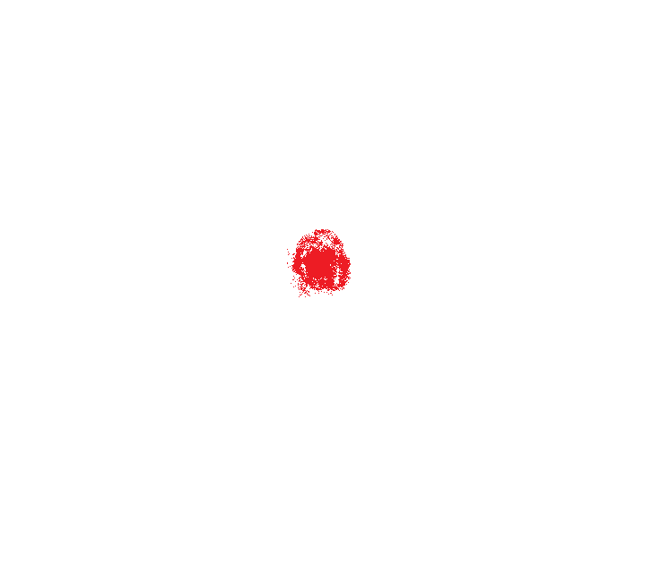

Figure 1 – Original Object Figure 2 – Captured Object

[Introduce the physics behind the project]

For astronomical imaging, stars act like points of light. This makes the point spread function of the object feasible to estimate. This allows us to estimate the fuzziness of each object and attempt to correct for it.

[Motivation for problem]

**Methods**

[Clearly state problem]

To fix the image, we will assume the path through the instrument is optically perfect. It image is convolved with a point spread function (PSF). The point spread function describes the distortion in terms of the pathway a theoretical point source of light. Usually, such a point source contributes a small area of fuzziness to the final image. If this function can be determined, then it’s possible to convolve the acquired image with that. Obtaining the original, undistorted image. [Develop tools will be using]

Deconvolution maps to division in the Fourier co-domain. This allows deconvolution to be easily applied with experimental data that are subject to a Fourier transform.